ChatBots Using OpenAI APIs

A Synopsis Submitted

in Partial Fulfilment of the Requirements

for the Course of

# **Major Project - II**

in

Third year

**Bachelor of Technology**

specialisation

In

# **Artificial Intelligence and Machine Learning**

Under

**Dr. Piyush Chauhan**

**Assistant Professor** - **Senior Scale**

Department of Informatics

UPES, Dehradun

by

|  |  |  |
| --- | --- | --- |
| **Name** | **SAPID** | **Specialisation** |
| Abhijeet Jain | 500075391 | AI & ML |
| Wamiq Zafar | 500075916 | IT Infrastructure |

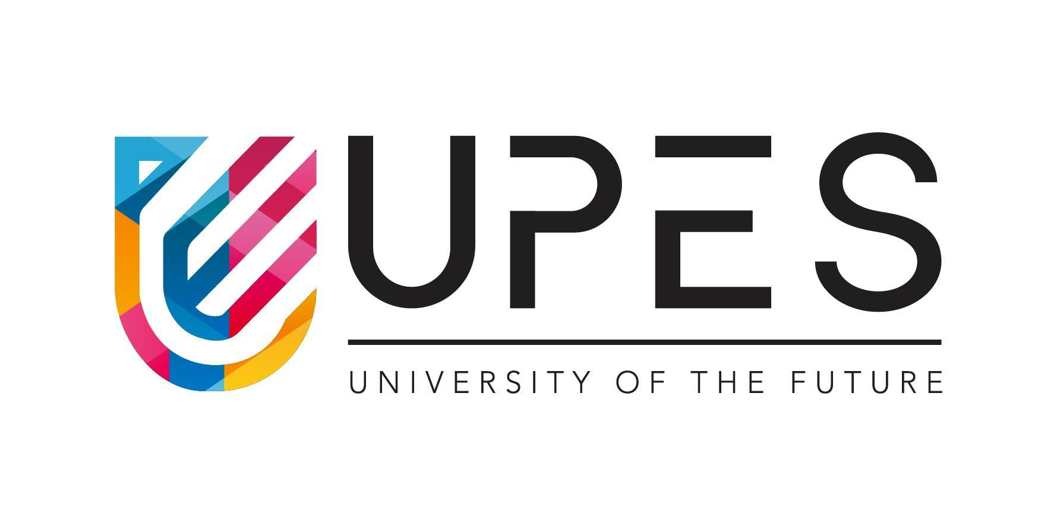

DEPARTMENT OF INFORMATICS

SCHOOL OF COMPUTER SCIENCE

UNIVERSITY OF PETROLEUM AND ENERGY STUDIES, BIDHOLI, DEHRADUN, UTTRAKHAND, INDIA

**Synopsis**

**Introduction**

The development of chatbot technology has revolutionized the way people interact with machines, making information more accessible and user-friendly. In this project, we aim to create a chatbot application that leverages the advanced capabilities of OpenAI APIs for NLP processing and the user-friendly interface of Tkinter for GUI design. The application will allow users to interact with the chatbot using natural language inputs and receive relevant responses in real-time.

The chatbot will understand user requests and generate appropriate answers, providing a seamless and intuitive interaction experience. This project has the potential to transform the way individuals and businesses integrate chatbots into their operations, making information more accessible and improving the efficiency of communication. With the integration of cutting-edge NLP technology and a user-friendly interface, this chatbot application has the potential to greatly enhance the way people interact with machines.

**Motivation**

The motivation for this project stems from the increasing demand for chatbots as a means of communication and information dissemination. The convenience and efficiency offered by chatbots have made them an increasingly popular choice for individuals and businesses looking to improve their interactions with customers, employees, and other stakeholders. However, not all chatbots are created equal, and some lack the advanced capabilities needed to effectively understand and respond to user requests.

This project aims to address this issue by leveraging the power of OpenAI APIs to provide a chatbot that can understand and respond to user requests in a meaningful and relevant manner. Additionally, the use of Tkinter for GUI design provides a user-friendly and intuitive interface, making the chatbot accessible and easy to use for a wide range of users. The integration of these cutting-edge technologies has the potential to greatly improve the efficiency and effectiveness of chatbot interactions, making information more accessible and user-friendly.

.

**Related Work**

Related work in the field of chatbot development and integration of NLP technology includes a variety of projects and applications that aim to enhance the capabilities of chatbots and make them more accessible to users. Some of the notable related works include:

* Dialogflow by Google: Dialogflow is a platform for building conversational interfaces powered by Google’s NLP technology. It allows developers to build chatbots for a variety of applications and platforms, including websites, mobile apps, and messaging platforms.
* Microsoft Bot Framework: Microsoft Bot Framework is a comprehensive platform for building, deploying, and integrating chatbots. It provides tools for developing and integrating NLP models, as well as a wide range of templates and tools for creating custom chatbots.
* IBM Watson Assistant: IBM Watson Assistant is a conversational AI platform that provides NLP technology and a wide range of tools for building and integrating chatbots. It allows developers to create chatbots that can understand and respond to natural language inputs.
* Amazon Lex: Amazon Lex is a service for building conversational interfaces powered by Amazon’s NLP technology. It provides a platform for building chatbots that can understand and respond to natural language inputs.

**Methodology**

* Requirements gathering and analysis: The requirements for the chatbot application will be gathered and analyzed to ensure that all necessary functionality is included.
* GUI Design using Tkinter: The Tkinter library will be used to design the GUI for the chatbot application, providing a user-friendly and intuitive interface for users to interact with the chatbot.
* Integration of OpenAI APIs: OpenAI APIs will be integrated into the application to enable NLP processing and generation of relevant responses.
* User interaction and continuous improvement: The chatbot application will be made available for use, and user interactions will be monitored to continuously improve the NLP processing and response generation capabilities of the chatbot.
* Documentation: Detailed documentation will be provided to ensure that the chatbot application is easy to understand and use, and to facilitate future maintenance and updates.

**Plan of Work**

|  |  |
| --- | --- |
| **February** | Research and setting up resources. |
| **March** | Learning and implementing the application. |
| **April** | Testing and work on user interface. |
| **May** | Documentation and evaluation of project. |

**References**

* Tkinter documentation: <https://docs.python.org/3/library/tk.html>
* OpenAI API documentation: <https://beta.openai.com/docs/api-reference>
* Introduction to NLP with OpenAI GPT-3: <https://towardsdatascience.com/introduction-to-nlp-with-openai-gpt-3-7c7b67b0c7b7>
* Chatbot development with Dialogflow: <https://cloud.google.com/dialogflow/docs/>
* Building chatbots with Microsoft Bot Framework: <https://docs.microsoft.com/en-us/azure/bot-service/>
* IBM Watson Assistant: <https://cloud.ibm.com/docs/services/assistant>
* Amazon Lex: <https://aws.amazon.com/lex/>